**8-BIT DIVISION**

**EXP NO: 4**

**AIM:** To write an assembly language program to implement 8-bit division using 8085 processor.

**ALGORITHM:**

1. Start the program by loading a register pair with the address of memory location.
2. Move the data to a register.
3. Get the second data and load it into the accumulator.
4. Subtract the two register contents.
5. Increment the value of the carry.
6. Check whether the repeated subtraction is over.
7. Store the value of quotient and the reminder in the memory location.
8. Halt.

**PROGRAM:**

LDA 4201

MOV B, A

LDA 4200

MVI C,00

AGAIN: CMP B

JC STORE

SUB B

INR C

JMP AGAIN

STORE: STA 4203

MOV A, C

STA 4202

HLT

**INPUT:**

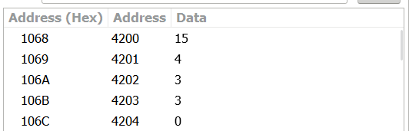

**OUTPUT:**

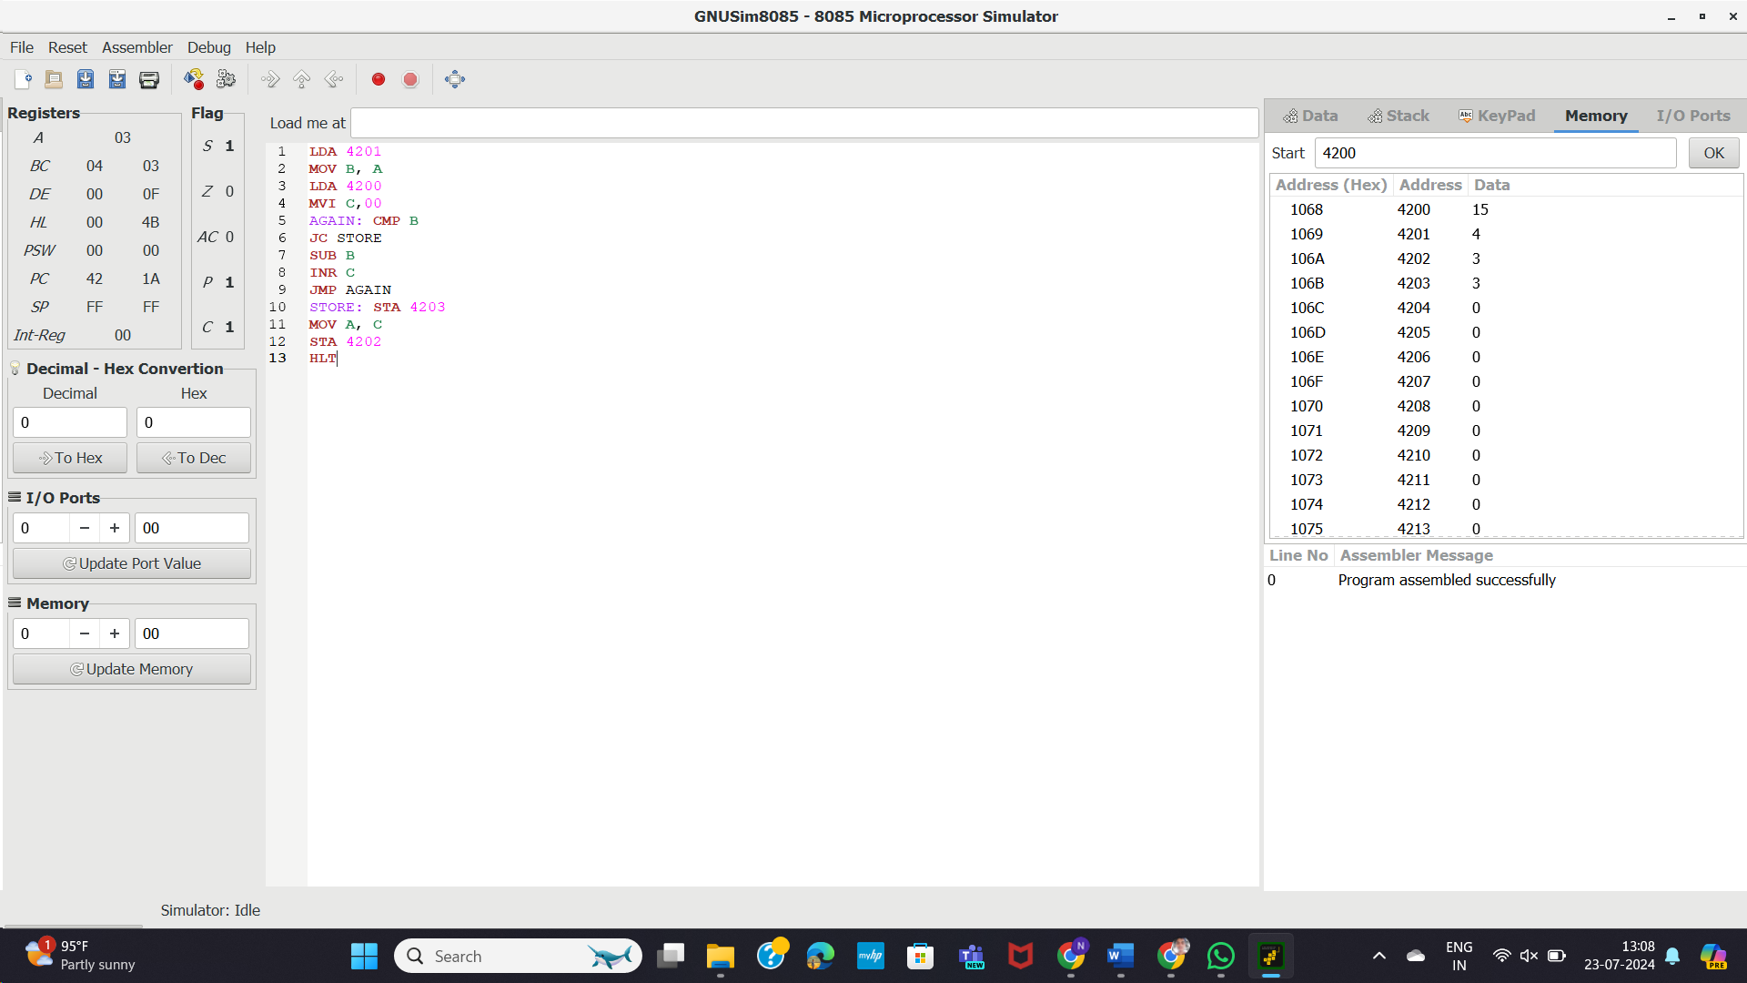

**RESULT:** Thus the program was executed successfully using 8085 processor simulator.